The Garth
Coulby Farm Way
Coulby Newham
Middlesbrough TS8 OUG
Telephone: 01642 595353

Web: www.rosewoodacademy.co.uk

Headteacher: Mr Paul Cowley

23rd Jan 2020

Dear Parents/Guardians

I am writing to inform you that we have decided to update our school logo. We wanted a more modern look whilst retaining some of the features of the original logo. You can see the new logo at the top of this letter. That is the style we will use on correspondence and some signage. The images below show the style we will use on clothing and sports equipment:
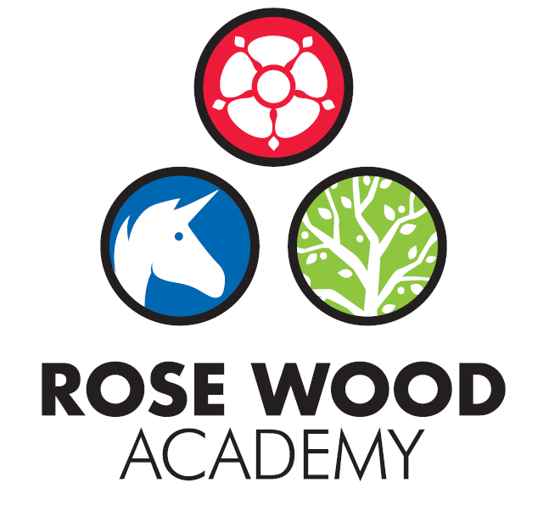
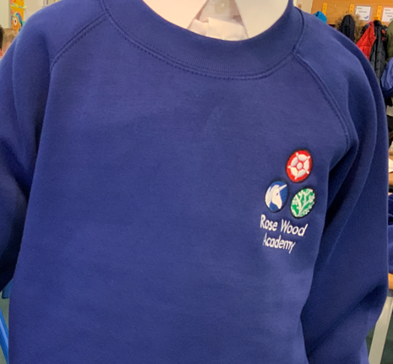

We decided to launch this now to give you plenty of notice prior to purchasing any new uniforms for next year. The new uniform is available now but there is no expectation that any child should wear it. The existing school uniform is perfectly acceptable and will remain so for as long as you wish your child to wear it. The uniform suppliers are selling the existing tops at a reduced price if you wish to take advantage and they can be worn for as long as they last. It is also perfectly acceptable for your child/children to wear non badged uniform. If you have any concerns or issues regarding the change please contact me to discuss.

Kind regards,
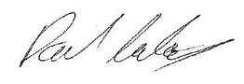

Mr P Cowley
Head Teacher

